Fuzzy Logic:

The term **fuzzy** refers to things that are not clear or are vague. In the real world many times we encounter a situation when we can’t determine whether the state is true or false, their fuzzy logic provides very valuable flexibility for reasoning. In this way, we can consider the inaccuracies and uncertainties of any situation.

Fuzzy Logic is a form of many-valued logic in which the truth values of variables may be any real number between 0 and 1, instead of just the traditional values of true or false. It is used to deal with imprecise or uncertain information and is a mathematical method for representing vagueness and uncertainty in decision-making.

Fuzzy Logic is used in a wide range of applications, such as control systems, image processing, natural language processing, medical diagnosis, and artificial intelligence.

The fundamental concept of Fuzzy Logic is the membership function, which defines the degree of membership of an input value to a certain set or category. The membership function is a mapping from an input value to a membership degree between 0 and 1, where 0 represents non-membership and 1 represents full membership.

Fuzzy Logic is implemented using Fuzzy Rules, which are if-then statements that express the relationship between input variables and output variables in a fuzzy way. The output of a Fuzzy Logic system is a fuzzy set, which is a set of membership degrees for each possible output value.

## Operations on Fuzzy Sets

Having two fuzzy sets A’ and B’, the universe of information U and an element 𝑦 of the universe, the following relations express the union, intersection and complement operation on fuzzy sets.

### **Union/Fuzzy ‘OR’**

Let us consider the following representation to understand how the **Union/Fuzzy ‘OR’** relation works

μA˜∪B˜(y)=μA˜∨μB˜ ∀y∈U

### **Intersection/Fuzzy ‘AND’**

Let us consider the following representation to understand how the **Intersection/Fuzzy ‘AND’** relation works −

μA˜∩B˜(y)=μA˜∧μB˜∀y∈U

### **Complement/Fuzzy ‘NOT’**

Let us consider the following representation to understand how the **Complement/Fuzzy ‘NOT’** relation works −

μA˜=1−μA˜(y)y∈U

**1. Max min composition. 2. Max product composition.**

Two fuzzy relations are given by,

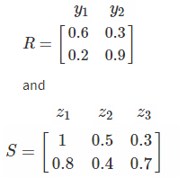

Obtain fuzzy relation T as a composition between the fuzzy relation.

**Solution:** The composition between two fuzzy relations is obtained by,

[a] Max – min composition.

[b] Max-product composition.

**[a] Max – min composition.**

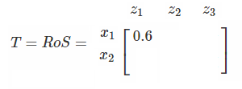

**Max product composition.**

T = R . S

MT(x1,z1) = max [MR(x1,y1).Ms(y1,z1)

MR(x1,y2).MS(y2,z1)]

= max (0.6, 0.24) = 0.6

## Features of Membership Functions

We will now discuss the different features of Membership Functions.

### **Core**

For any fuzzy set A’, the core of a membership function is that region of universe that is characterize by full membership in the set. Hence, core consists of all those elements y of the universe of information such that,

μA˜(y)=1

### **Support**

For any fuzzy set A’, the support of a membership function is the region of universe that is characterize by a nonzero membership in the set. Hence core consists of all those elements y of the universe of information such that,

μA˜(y)>0

### **Boundary**

For any fuzzy set A’, the boundary of a membership function is the region of universe that is characterized by a nonzero but incomplete membership in the set. Hence, core consists of all those elements y of the universe of information such that,

1>μA˜(y)>0

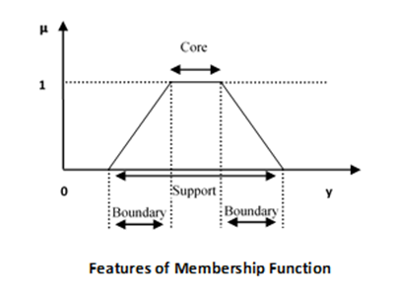

Functional Blocks of FIS

The following five functional blocks will help you understand the construction of FIS −

* **Rule Base** − It contains fuzzy IF-THEN rules.
* **Database** − It defines the membership functions of fuzzy sets used in fuzzy rules.
* **Decision-making Unit** − It performs operation on rules.
* **Fuzzification Interface Unit** − It converts the crisp quantities into fuzzy quantities.
* **Defuzzification Interface Unit** − It converts the fuzzy quantities into crisp quantities. Following is a block diagram of fuzzy interference system.

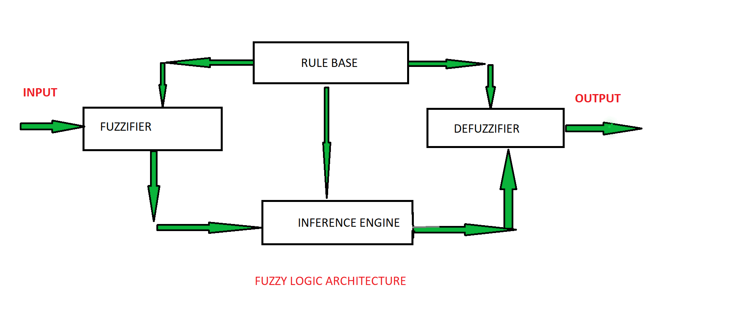

**ARCHITECTURE**   
  
Its Architecture contains four parts :

* RULE BASE: It contains the set of rules and the IF-THEN conditions provided by the experts to govern the decision-making system, on the basis of linguistic information. Recent developments in fuzzy theory offer several effective methods for the design and tuning of fuzzy controllers. Most of these developments reduce the number of fuzzy rules.
* FUZZIFICATION: It is used to convert inputs i.e. crisp numbers into fuzzy sets. Crisp inputs are basically the exact inputs measured by sensors and passed into the control system for processing, such as temperature, pressure, rpm’s, etc.
* INFERENCE ENGINE: It determines the matching degree of the current fuzzy input with respect to each rule and decides which rules are to be fired according to the input field. Next, the fired rules are combined to form the control actions.
* DEFUZZIFICATION: It is used to convert the fuzzy sets obtained by the inference engine into a crisp value. There are several defuzzification methods available and the best-suited one is used with a specific expert system to reduce the error.

Methods of FIS

Let us now discuss the different methods of FIS. Following are the two important methods of FIS, having different consequent of fuzzy rules −

* Mamdani Fuzzy Inference System
* Takagi-Sugeno Fuzzy Model (TS Method)

## Types of Decision

Making We will now understand the different types of decision making.

### **Individual Decision Making**

In this type of decision making, only a single person is responsible for taking decisions. The decision making model in this kind can be characterized as −

### **Multi-person Decision Making**

Decision making in this case includes several persons so that the expert knowledge from various persons is utilized to make decisions.

Calculation for this can be given as follows −

### **Multi-attribute Decision Making**

Multi-attribute decision making takes place when the evaluation of alternatives can be carried out based on several attributes of the object. The attributes can be numerical data, linguistic data and qualitative data.